Multiplying Decimals by a Whole Number

12.9
x 8

3.2
x .5

Step 1: Move the decimal points to make whole numbers! (Make a note of how many on the side)
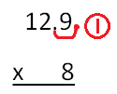
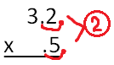

Step 2: Multiply the whole numbers normally.
32
x 5
160
129
x 8
1032

Step 3: Add the appropriate number of decimal places back in the product.
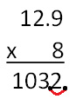
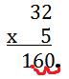

12.9 x 8 = 103.2
3.2 x .5 = 1.60

