Dividing with a Decimal in the Divisor

Rule: You cannot have a decimal in the divisor!!

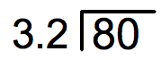

Step 1: Move the decimal in the divisor to make it a whole number.
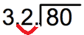

Step 2: Move the decimal point in the dividend as many places as you did in the divisor.

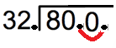
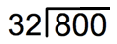

Step 3: Divide normally. (Note: you do not need to add decimals back at the end)
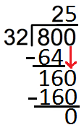
80 ÷ 3.2 = 24

