Dividing with a Decimal in the Dividend
Rule: “Pop it Up!”

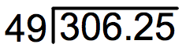

Step 1: Pop the decimal point up into the quotient.

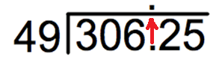

Step 2: Divide normally.
